1200mm BRIDGE TILE SAW

MODEL: FS350-1200

Owner’s manual & operating instructions

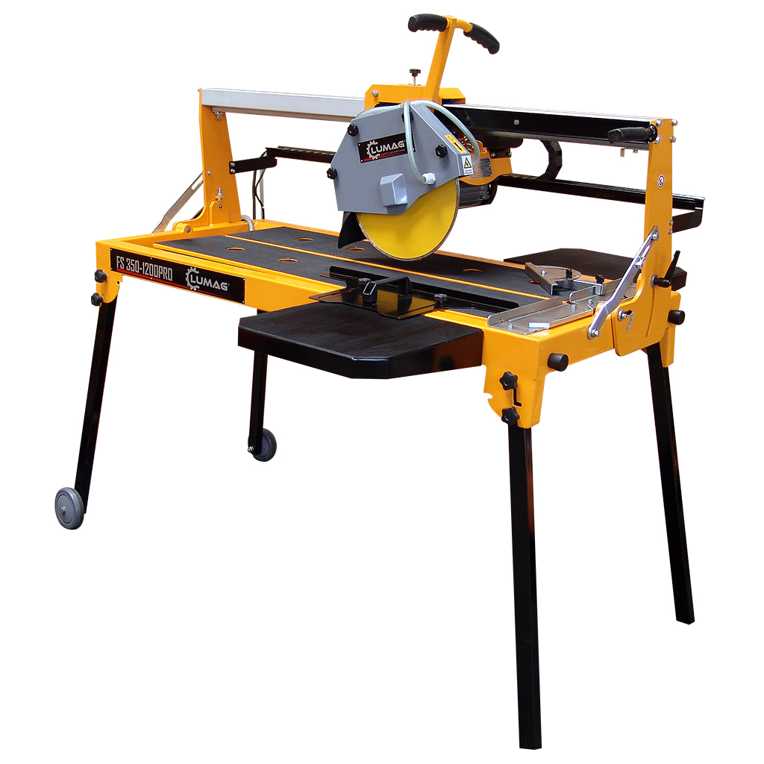



SAVE THIS MANUAL
You will need this manual for the safety warnings and precautions, assembly, operating, inspection, maintenance and cleaning procedures, parts list and assembly diagram.
Keep your invoice with this manual. Write the invoice number on the inside of the front cover. Keep this manual and invoice in a safe and dry place for future reference.

Specification
Motor | 220~240V V/50Hz/1PH
Motor Power | 2.2 KW
Blade Speed | 2800RPM
Blade Capacity | 350mm
Arbor Size | 25.4mm
Max. rip cut length | 1200mm

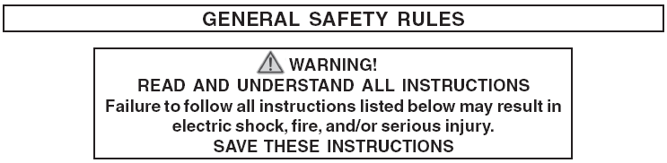



1. Keep your work area clean and well lit. Cluttered and dark areas invite accidents.
2. Do not operate power tools in explosive atmospheres, such as in the
presence of flammable liquids, gases, or dust. Power tools create sparks
which may ignite the dust or fumes.
3. Keep bystanders, children, and visitors away while operating a power tool. Distractions can cause you to lose control. Protect others in the work area from debris such as chips and sparks. Provide barriers or shields as needed.


4. Grounded tools must be plugged into an outlet properly installed and
grounded in accordance with all codes and ordinances. Never remove the
grounding prong or modify the plug in any way. Do not use any adapter
plugs. Check with a qualified electrician if you are in doubt as to whether
the outlet is properly grounded. If the tools should electrically malfunction or
break down, grounding provides a low resistance path to carry electricity away
from the user.
5. Avoid body contact with grounded surfaces such as pipes, radiators,
ranges, and refrigerators. There is an increased risk of electric shock if your
body is grounded.
6. Do not expose power tools to rain or wet conditions. Water entering a power tool will increase the risk of electric shock.
7. Do not abuse the Power Cord. Never use the Power Cord to carry the tools or pull the Plug from an outlet. Keep the Power Cord away from heat, oil, sharp edges, or moving parts. Replace damaged Power Cords immediately. Damaged Power Cords increase the risk of electric shock.
8. When operating a power tool outside, use an outdoor extension cord
marked “W-A” or “W”. These extension cords are rated for outdoor use, and
reduce the risk of electric shock.


9. Stay alert. Watch what you are doing, and use common sense when
operating a power tool. Do not use a power tool while tired or under the
influence of drugs, alcohol, or medication. A moment of inattention while
operating power tools may result in serious personal injury.
10. Dress properly. Do not wear loose clothing or jewelry. Contain long hair.
Keep your hair, clothing, and gloves away from moving parts. Loose
clothes, jewelry, or long hair can be caught in moving parts.
11. Avoid accidental starting. Be sure the Power Switch is off before plugging in. Carrying power tools with your finger on the Power Switch, or plugging in power tools with the Power Switch on, invites accidents.
12. Remove adjusting keys or wrenches before turning the power tool on. A
wrench or a key that is left attached to a rotating part of the power tool may result in personal injury.
13. Do not overreach. Keep proper footing and balance at all times. Proper
footing and balance enables better control of the power tool in unexpected
situations.
14. Use safety equipment. Always wear eye protection. Dust mask, non-skid
safety shoes, hard hat, or hearing protection must be used for appropriate
conditions.


15. Do not force the tool. Use the correct tool for your application. The correct tool will do the job better and safer at the rate for which it is designed.
16. Do not use the power tool if the Power Switch does not turn it on or off.
Any tool that cannot be controlled with the Power Switch is dangerous and must
be replaced.
17. Disconnect the Power Cord Plug from the power source before making any adjustments, changing accessories, or storing the tool. Such preventive safety measures reduce the risk of starting the tool accidentally.
18. Store idle tools out of reach of children and other untrained persons. Tools are dangerous in the hands of untrained users.
19. Maintain tools with care. Keep cutting tools sharp and clean. Properly
maintained tools with a sharp cutting edge are less likely to bind and are easier to control. Do not use a damaged tool. Tag damaged tools “Do not use” until repaired.
20. Check for misalignment or binding of moving parts, breakage of parts, and any other condition that may affect the tool’s operation. If damaged, have the tool serviced before using. Many accidents are caused by poorly
maintained tools.
21. Use only accessories that are recommended by the manufacturer for your model. Accessories that may be suitable for one tool may become hazardous when used on another tool.


22. Tool service must be performed only by qualified repair personnel. Service or maintenance performed by unqualified personnel could result in a risk of injury.
23. When servicing a tool, use only identical replacement parts. Use of unauthorized parts or failure to follow maintenance instructions may create a risk of electric shock or injury.

1. Use the right product for the right job. There are certain applications for which this product was designed. Do not use small equipment, tools, or attachments to do the work of larger industrial equipment, tools, or attachments. Do not use this product for a purpose for which it was not intended.
2. WARNING! Keeps hands and fingers away from cutting area and Saw Blade.
3. Make sure Blade Cover is always securely in place. Never operate the
Stone Saw without the Blade Cover. Make sure the Blade Cover does not touch the Saw Blade or any other part of the Saw.
4. Do not handle the Power Switch with wet hands.
5. Make sure the Stone Saw is located on a flat, level, sturdy surface capable of supporting the weight of the Saw and workpieces.
6. Keep all electrical connections dry and off the ground.
7. Never leave the Stone Saw unattended when it is plugged into an electrical outlet. Turn off the Stone Saw, and unplug it from its electrical outlet.
8. Avoid splashing water on the Motor, Power Switch, Power Cord, or any
other electrical component. Make sure to stand on a dry, insulated surface
such as a rubber mat while using the Stone Saw.
9. To avoid accidental injury, always wear heavy-duty work gloves when
changing the Saw Blade.
10. Before using the Stone Saw, make sure the Saw Blade is properly mounted on the Saw Spindle. Make sure the Saw Blade is balanced, and is not cracked or bent.
10. The Saw Blade will become hot while cutting. Allow the Saw Blade to
completely cool before handling.
11. Maintain a safe working environment. Keep the work area well lit. Make sure there is adequate surrounding workspace. Always keep the work area free of obstructions, grease, oil, trash, and other debris. Do not use a power tool in areas near flammable chemicals, dusts, and vapors.
12. Avoid unintentional starting. Make sure you are prepared to begin work
before turning on the Stoen Saw.
13. Always lock the supporting frames in position before transporting the Stone Saw.

Assembly
- Install the four legs.
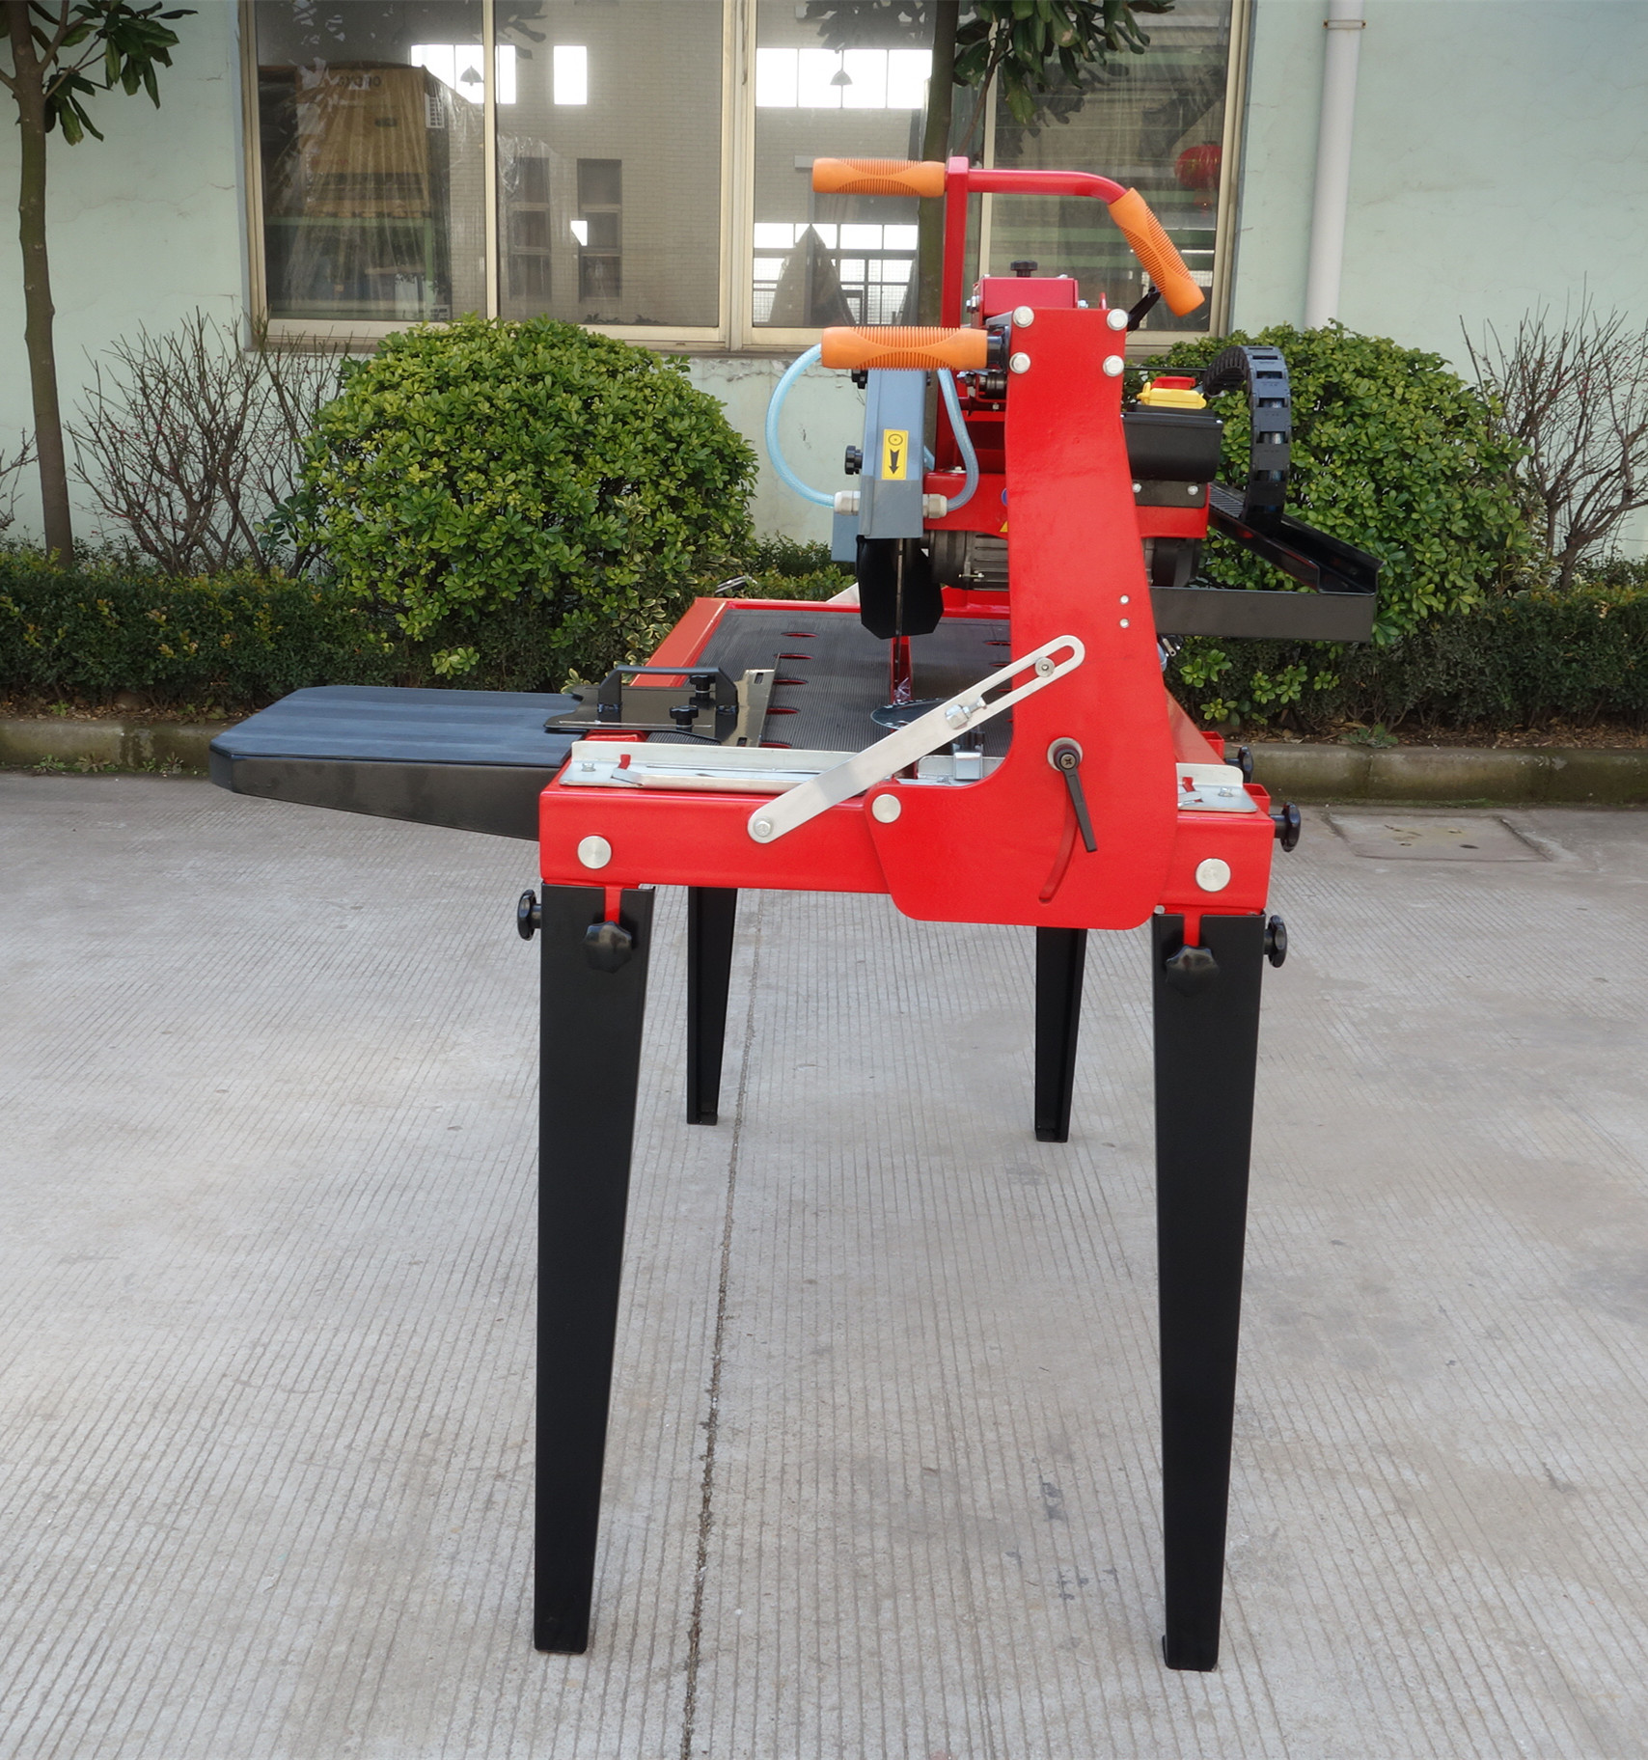

2,Install the Extension side table
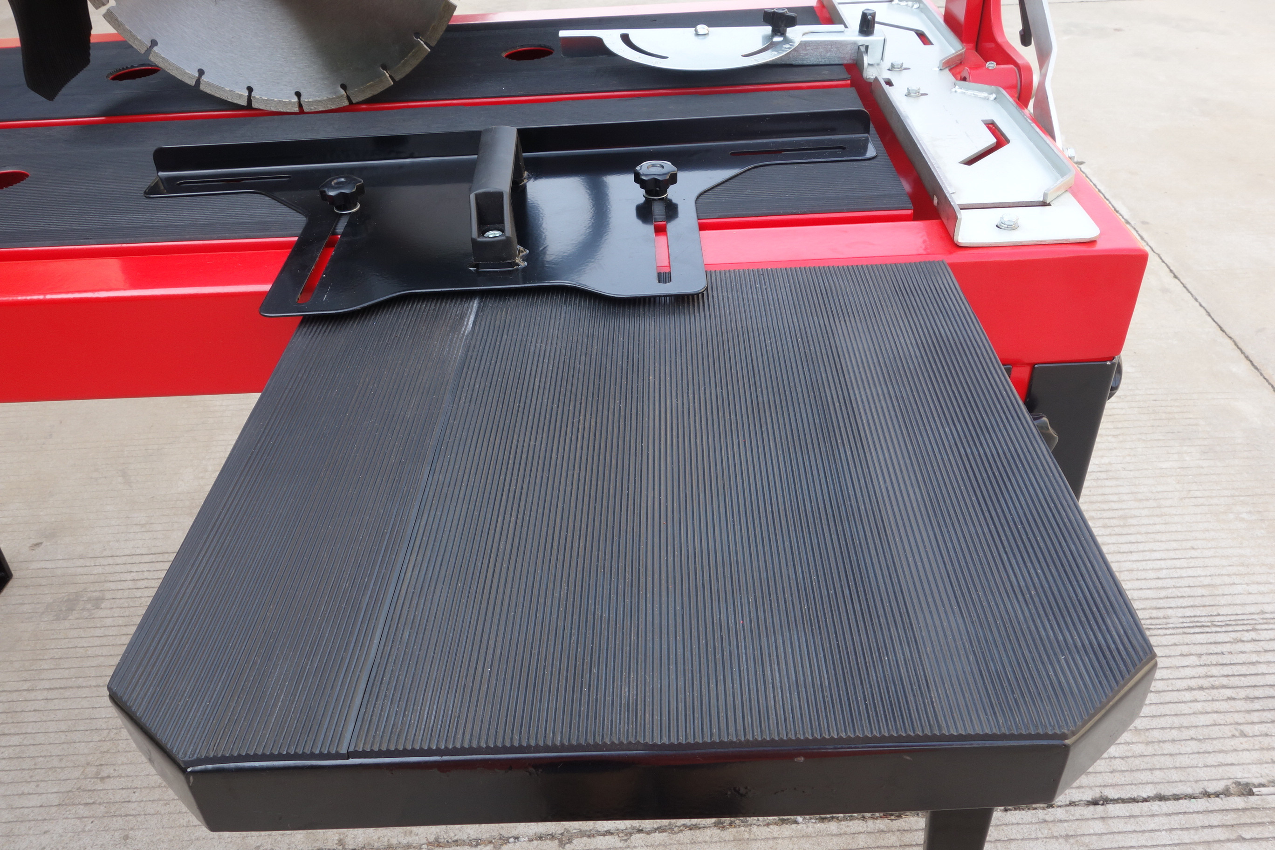

3, Adjust and check the Extension side table is in the same height with the main table
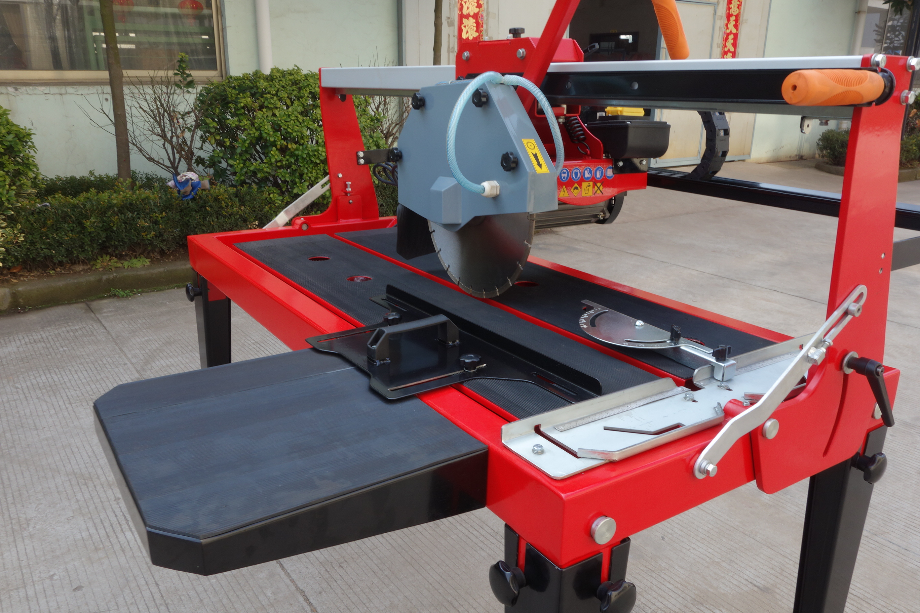

Cutting instruction
1,before operation
- Install the blade: this model is designed for 300mm blade, remove the Outer Flange and Nut, and install the blade, please keep in mind the blade direction should be the same as the direction shown on the blade guard. And please tight the outer flange and nut finally.
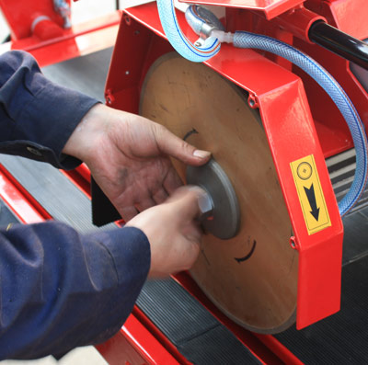
2)Make sure there are enough water in the water tank.
3）Adjust the guiding rule to right positioniand locking
1,Rip cutting
Position and press the tile on the table, and turn on the motor, pull the handle to finish the rip cutting.

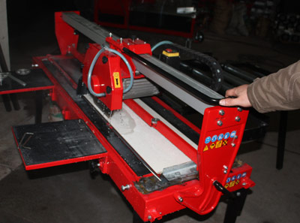
2，45 Degree Angle Cutting:
1)Loose the two Locking Handle located on both end of the Cutting Head，Pivot the Cutting Head and retighten the two Locking Handles, make sure the blade is 45 degree on the table
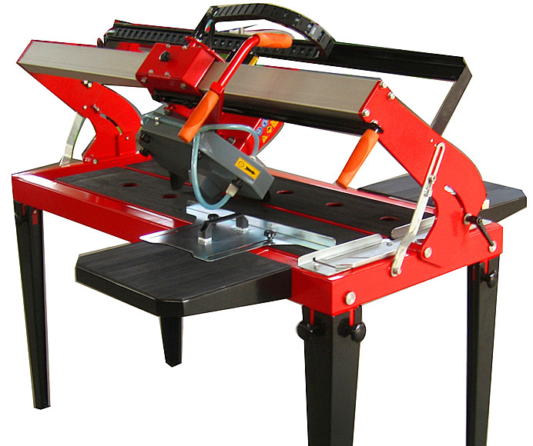

2, Position and press the tile on the table, and turn on the motor, pull the handle to finish the 45 degree cutting.

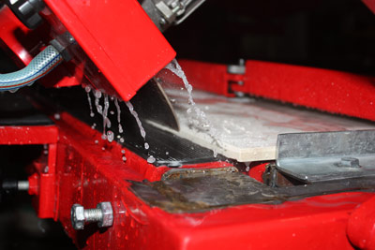

Exploded Diagram
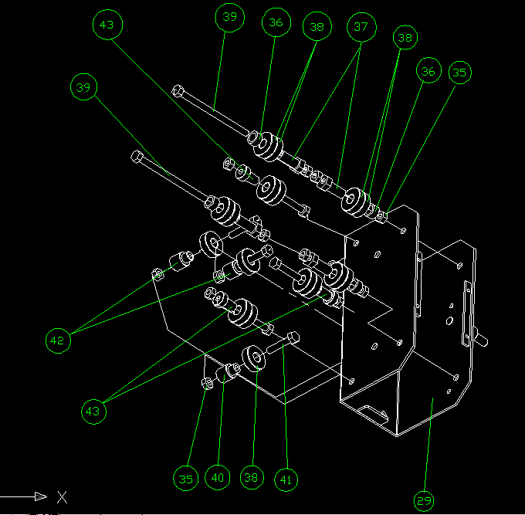

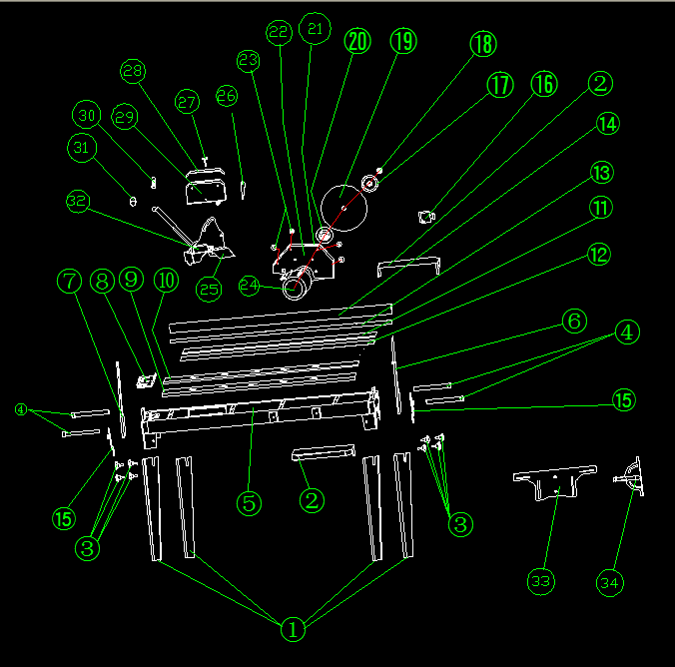

Parts No . | Description | Qty. | Annotation | Parts No . | Description | Qty. | Annotation
1 | Supporting Leg | 4 |  | 23 | M6A djustable bolt | 4
2 | Assistant work table | 2 |  | 24 | Motor | 1
3 | M10Adjustable bolt | 8 |  | 25 | Motor plate | 1
4 | Transport Handle | 4 |  | 26 | M10 locking nut | 1
5 | Tank rack | 1 |  | 27 | M6 locking nut | 4
6 | Right column | 1 |  | 28 | Sliding rack cover | 1
7 | Left column | 1 |  | 29 | Sliding rack | 1
8 | Guiding rule | 1 |  | 30 | Spring | 1
9 | Right table panel | 1 |  | 31 | Plastic handle set | 1
10 | Left table panel | 1 |  | 32 | Switch | 1
11 | Rubber on left panel | 1 |  | 33 | Parallelguiding rule | 1
12 | Rubber on right panel | 1 |  | 34 | Fan-shaped ruler | 1
13 | Aluminum rail steel | 1 |  | 35 | M8 Bolt | 12
14 | Aluminum guide rail | 1 |  | 36 | φ12 cover pipe | 4
15 | 45 degree guiding stopper | 2 |  | 37 | Hexagon eccentric shaft | 4
16 | Water pump | 1 |  | 38 | 6201Bearing | 17
17 | Outer flange | 1 |  | 39 | M8*120 Outer hexagon screw | 2
18 | M20-lock nut | 1 |  | 40 | Eccentric spindle(2) | 1
19 | 350mm Blade | 1 |  | 41 | M8*40 Outer hexagon screw | 6
20 | Inner flange | 1 |  | 42 | Core shaft(2) | 2
21 | Blade Guard cover | 1 |  | 43 | Core shaft(1) | 3
22 | Blade Guard base | 1

