Specification No: |  |  | CTC100 / CTC150
Tool Name: |  |  | Concrete testing cube / mould.
Specification:
Available in both 100mm and 150mm internal width across flats.
Manufactured from high quality cast steel. 4-part clamped for ease of extraction. Surface ground and pre greased to ensure that all surfaces are free from rust and ready to use.
Weight: 7300g & 9800g

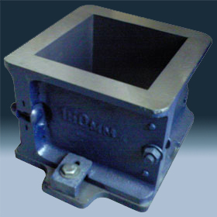

 | Length (mm) | Weight |  | Colour |  | RCL Part No
 | 100mm A/F | 7.8kgs |  | BLUE /natural |  | CTC100
 | 150mm A/F | 9.8kgs |  | BLUE /natural |  | CTC150
Status |  |  |  |  | Authority |  | Date Issued
Issue 1 |  |  |  |  | W Green |  | 07.04.2016
Remarks/Notes:
This product is not tested to BS requirements.

